1.https://j6662.quanqiusou.cn/
2.view-source:https://j6662.quanqiusou.cn/部分图片无alt标签
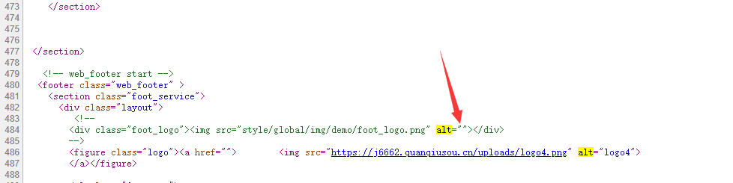
3.https://j6662.quanqiusou.cn/accessories-of-machine-1.html无描述内容，建议添加丰富

